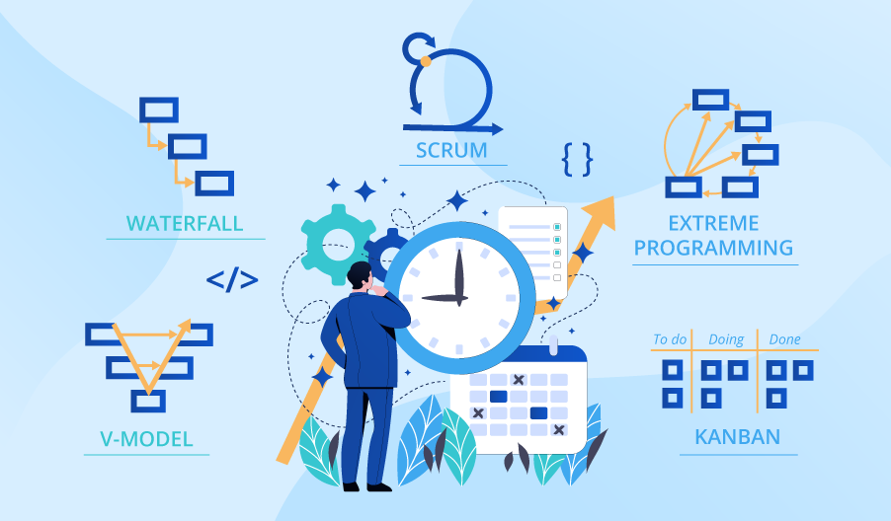

**SE423**

**Software Project Management**

**Assignment**

**Assignment 2.**

Answer the following questions:

1. Discuss three main differences between Project-based software engineering and Product-based software engineering.
2. How the projects perspective intersect with Software product line?

Submit your answers to LMS as PDF file.